Coronavirus: HR’s role
HR leaders should safeguard against the spread of the illness, without causing panic, experts say.
By: Andrew R. McIlvaine | February 10, 2020

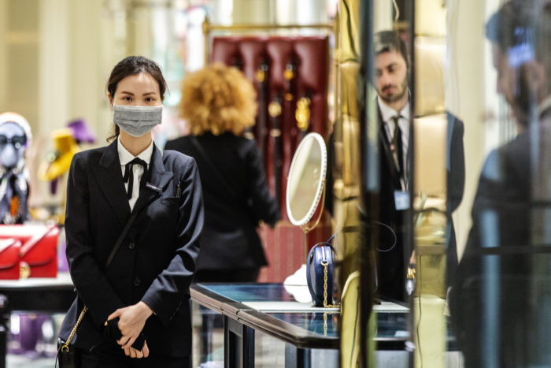
(Photo by Jenny Evans/Getty Images)

There’s a virus that’s currently ravaging the U.S. So far this season, it’s caused at least 22 million illnesses, 210,000 hospitalizations and 12,000 deaths.
The cause of this scourge is the general influenza virus, which is wreaking more havoc than usual across the country this winter. In 2018, the flu cost U.S. companies $18 billion in lost productivity, reports Gartner. However, a different virus has received far more media coverage and is stirring much more anxiety: the coronavirus, which has caused a near economic shutdown in China and has prompted travelers returning from that country to undergo special screening and possible quarantine.
Although organizations must take precautions to guard their employees from coronavirus, experts are concerned that fear and misinformation could ultimately land companies in legal jeopardy.
Attorney Bob Nichols, who counseled clients through the SARS virus of 2003 and the H1N1 virus of 2009, says misinformation about coronavirus may be a bigger threat in the U.S. at the moment than the virus itself. So far, only 18 cases have been reported in the U.S., although that number is likely to rise.
“The common flu, which is worse this year than most, is a much more significant threat to U.S. workers than the coronavirus,” says Nichols, a partner at Bracewell LP in Houston. “The most important thing HR leaders can do is to maintain that perspective and guard against over-reaction.”
By providing employees with accurate information about coronavirus, HR can maintain good order and protect the organization against potential liability, he says. The Centers for Disease Control and Prevention and the Occupational Safety and Health Administration have good information on their websites that HR can share with employees to ensure they’re relying on facts, not hearsay.

“Keep them aware of the CDC guidance on this topic and that will keep them calm,” says Nichols.
Fears about the coronavirus are understandable. As of Monday, the virus has killed more than 900 people in China—including 97 just on Feb. 9—and infected more than 40,000 globally, reports CNN. Scientists still aren’t entirely sure how the virus is transmitted and, for now, there is no vaccine to guard against it. Government agencies and pharmaceutical companies are working to develop a coronavirus vaccine, but it will be months before one is ready.
Nevertheless, companies shouldn’t allow fear to dictate their response to the threat or rumors to undermine employee morale.
“So as to avoid the spread of misinformation, HR should endeavor to ensure that employees aren’t sharing false information or gossiping about others,” says Susan Gross Sholinksy, a member of the employment, labor and workforce management practice at Epstein Becker Green.
Employers should also ensure that employees aren’t refusing to interact with colleagues and/or customers who are of Asian descent, she adds. Such behavior could lead to complaints about discrimination based on national origin and ethnicity, or it could even be “regarded as” disability discrimination.
“Rather, any actions taken (or avoided) should be based on whether an individual is likely to have been exposed to the virus,” Gross Sholinsky says.
“Simple But Important Steps”
The blanket media coverage of coronavirus is a good reminder for HR departments to emphasize preventative steps for guarding the workplace against all viruses, says Dr. Teresa Bartlett, senior vice president and medical director at Sedgwick. It’s especially timely given this season’s virulent flu outbreak.
Bartlett, who regularly consults with large company clients, says the No. 1 priority should be reviewing the company’s illness and absence policies and reminding employees about them.
“You don’t want people coming to work sick,” she says. “Set clear guidelines: ‘If you have a cough, a cold, upper-respiratory-illness symptoms, then we don’t want you at work.’ ”
When possible, allow people to work from home, says Bartlett.
It’s also important to have clear guidelines for workplace behavior, particularly during a flu outbreak, she says.
“Counsel employees to consider bumping elbows in lieu of shaking hands,” says Bartlett. Limit in-person meetings when possible, have hand sanitizer widely available and remind folks to cough into their elbow, not their hand, she says.
Common surfaces should be sanitized as often as possible, says Bartlett. “Doorknobs, elevator buttons, surfaces in the cafeteria—even toilet handles. Sanitizing these surfaces will go a long way.”
“These are simple but important steps,” she adds.
Lessons from Past Outbreaks
HR should have a plan ready to deploy should any major outbreak wreak havoc on company operations, says Bartlett. Such a plan should be created in partnership with other departments, including risk management, finance and IT, she says.
“Have something you can easily turn to during times like this,” says Bartlett.
Viral outbreaks that occurred earlier this century offer some useful lessons. A recent report from Gartner summarizes the steps taken by companies in the wake of the SARS and H1N1 viruses, which also originated in Asia and posed major potential disruptions to the global economy. In the wake of these outbreaks, American Express set up criteria to validate the threats of the next pandemic. It included both the impact on the business and the impact on the community to determine “thresholds for action.”
Goodyear focused on having a plan in place to ensure “critical roles” would be maintained in the event of a pandemic. Each business unit or region was asked to identify critical roles. Next, the company organized those roles by category: essential, temporary suspension and extended suspension (roles that could be suspended without undue harm to the business). Goodyear analyzed its talent bench to determine the difficulty of backfilling essential roles and made adjustments as necessary.
Organizations that have expatriate employees in China or a significant workforce there should carefully monitor travel guidelines to the region, says the Business Group on Health (formerly the National Business Group on Health). The BGH has released guidelines for employers that have significant business in Asia, noting that the U.S. State Dept. has advised against travel to China.
“The ‘Level 4: Do Not Travel’ advisory is the highest level of warning the State Department gives for travel,” the BGH notes.
For companies concerned that an employee was exposed to coronavirus, law firm Littler recommends instructing the employee to stay home for up to 14 days to ensure they don’t show symptoms of the virus. The employee should not return to work until they’ve received a “fitness-for-duty/return-to-work” notice.
If an employee has contracted coronavirus, Littler advises contacting the CDC and the local health department immediately and having a hazmat company clean and disinfect the workplace. Other employees should be notified and the company should consider allowing employees to expense medical tests for detecting the virus.
Companies must proceed carefully, taking care to ensure their policies for dealing with coronavirus don’t unwittingly discriminate: “It is possible, and indeed likely, that the coronavirus will disproportionately affect members of a protected class. While the risk of discrimination is likely small, employers must be cognizant of this fact … .” says Littler.
“Employers should ensure that employees aren’t improperly creating a hostile environment for employees of Asian descent due simply to their national origin or ethnicity,” says Gross Sholinsky.

